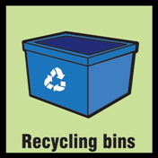 | By putting something in a recycling bin, you are cutting back on trash that would end up in a landfill and on the energy used to make something from scratch. | 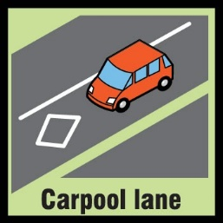 | If you are going to get a ride to school, why not take more than just yourself? The more people in a single car, the less other cars need to be on the road.
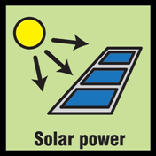 | Solar power is anything (solar panels, for example) that uses energy from the sun to create electricity. Solar power is great for the environment because it doesn’t burn gas. | 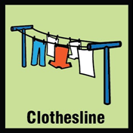 | Electric driers use a lot of energy—energy that likely comes from burning fossil fuels that release greenhouse gases. It doesn’t use any energy to just throw your clothes on a clothesline and wait for them to dry!
 | All that paper to make those disposable coffee cups has to come from somewhere. Those trees that were cut to make the cup could be sucking greenhouse gases from the atmosphere. Use a reusable mug when you can! | 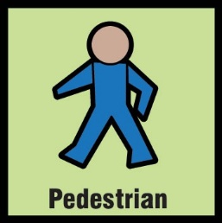 | Why not walk? It might take a bit longer, but you are also helping the Earth out by not driving. Driving releases greenhouse gases into the atmosphere, which contributes to global warming.
 | For every person on a bus, it’s one less car on the road. Cars and the gas they burn add greenhouse gases to the atmosphere, which contribute to global warming. |  | Riding a bike is a great way to cut back on pollution. Sure, it might be a little bit more work, but it doesn't release any harmful greenhouse gases into the air. Plus it keeps you fit and is fun too!
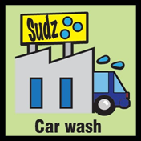 | Professional car washes use less water than if you wash a car yourself. If everyone in the U.S. who washes their car themselves took just one visit to the car wash we could save nearly 8.7 billion gallons of water. | 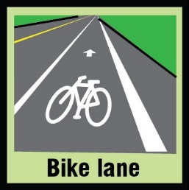 | Bike lanes encourage people to ride bikes. Riding bikes, unlike driving cars, does not add planet-warming greenhouse gases to the atmosphere.
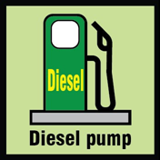 | Diesel gas is more efficient than regular unleaded gas, so diesel cars can get better mileage than regular cars. This can mean fewer greenhouse gases released into the atmosphere. | 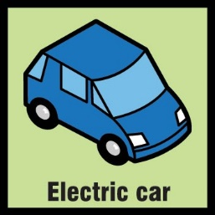 | Electric cars are great because they don’t use gasoline. Burning fossil fuels adds greenhouse gases to the environment and can cause our planet to warm.
 | Buying local food is good for the environment because it requires little or no transportation to get to you. |  | Food from a farmer's market comes from nearby. Buying close food means less energy is required to transport it, which means less gas is burned to get the food to you.
 | The plants in gardens help remove greenhouse gases from the atmosphere. They also can produce locally-grown food. Locally-grown food is good because it doesn’t require a lot of gas to transport. | 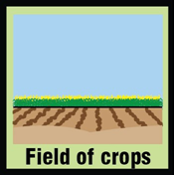 | Crops, like other plants, remove greenhouse gases from the atmosphere. Greenhouse gases cause our planet to warm.
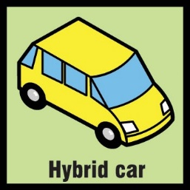 | Hybrid cars use both gas and electricity. Because they use electricity, they burn less gas and are better for the environment. |  | For every person raking leaves by hand, that is one less person using a leaf blower. Leaf blowers use lots of energy and can release greenhouse gases and pollution into the atmosphere.
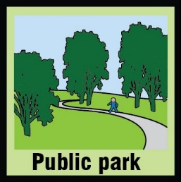 | Parks are great habitats for animals and plants. They also protect land from other developments—like factories, houses, or roads—that can release greenhouse gases into the atmosphere and cause it to warm. |  | Trash is an eyesore and it can be harmful to animals and damage natural ecosystems. Properly disposing of it is a great way to help the environment.
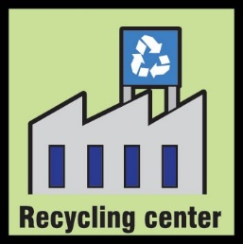 | Recycling centers turn old things into material for new things. Recycling means less pollution and less fuel burned to make the energy needed to produce new things. | 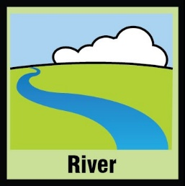 | Rivers provide habitats for animals and plants and help vegetation grow. Vegetation can remove greenhouse gases from the atmosphere.
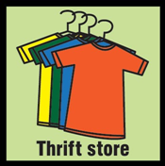 | No matter how you look at it, throwing clothes and other goods away can be very wasteful. You can cut back on waste and energy by donating clothes and other goods to a thrift store. | 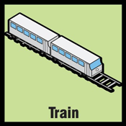 | Trains transport lots of people and goods. If all those people drove cars, or all those goods were trucked, then they would be releasing a lot more planet-warming greenhouse gases into the atmosphere.
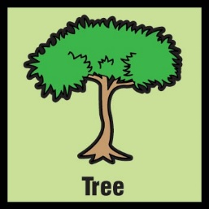 | Trees are great because they remove greenhouse gases from the atmosphere. A single tree will absorb one ton of carbon dioxide over its lifetime. |  | A tree nursery is great because planting and growing trees removes greenhouse gases from the atmosphere.
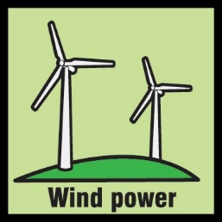 | Wind power is any type of power that comes from wind—anything from massive wind-turbines to small windmills. Wind power is great for the environment because it doesn’t burn gas. |  | Yard sales happen when people sell all the old things they don’t need anymore. This cuts back on trash and also promotes recycling.
Ecologist  Green Career: | Ecology is the study of the relationships between living things and their surroundings, or environment. Scientists who work in ecology are called ecologists. Ecologists examine how living things depend on one another for survival. They also study how living things use such natural resources as air, soil, and water to stay alive. | Meteorologist  Green Career: | The weather on Earth is always changing. Meteorology is a field of science that studies the changes in weather on a day-to-day basis in a specific place. Scientists who study meteorology are called meteorologists. Using various tools, meteorologists forecast whether it will rain or snow and whether it will be warm or cold.
Climatologist  Green Career: | A climatologist is a scientist who studies the climate. This field in the sciences is related to meteorology, the study of weather, except that it looks at long-term trends and the history of the climate, rather than examining weather systems in the short term like meteorologists do. | Social Scientist  Green Career: | The social sciences are fields of study about human life and behavior. People who study social sciences look at how people think and act. They also study how people form groups and relate to other people.  The main social sciences are anthropology, economics, political science, psychology, and sociology.
Engineer  Green Career: | Engineers solve problems. They use chemistry, physics, and math to figure out the best way to create new things or to improve existing things. The goal of engineers is to design things that can solve economic, environmental, or social problems. | Geographer  Green Career: | Geography is a science that deals with Earth's surface. People who study geography are called geographers. Geographers are interested in Earth's physical features, such as mountains, deserts, rivers, and oceans. They are also interested in the ways that people affect and are affected by the natural world.
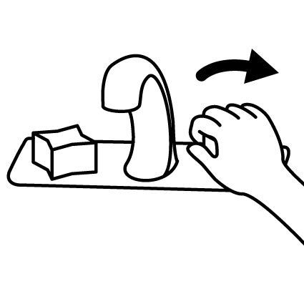  Turn off the Tap | Just by turning off the tap while you brush your teeth in the morning and before bedtime, you can save up to 8 gallons of water! That adds up to more than 200 gallons a month, enough to fill a huge fish tank that holds 6 small sharks! The energy used to pump, treat and heat water all contribute to our carbon footprints. | Turn it off | Turn off the TV if no one is watching. The energy powering your TV is, more likely than not, from the burning of fossil fuels. Fossil fuels account for 86% of annual energy use in the U.S.
Quiz Question! | True or False: Fossil fuels are renewable, meaning they can never run out.  False: Fossil fuels are non-renewable energy sources that formed more than 300 million years ago - long before dinosaurs roamed the Earth. Fossil fuels are made up of plant and animal matter. When plants and animals died, their bodies decomposed and were buried under layers of earth. Millions of years later we have the three forms of fossil fuel: Oil, natural gas, and coal. | Quiz Question! | True or False: Natural gas is lighter than air.  True: Natural gas is made out of methane, which is a simple chemical compound made up of carbon and hydrogen atoms. Because you can't smell or see natural gas, it is mixed with a chemical to give it a stinky smell - like rotten eggs. That way, it's easy to tell if there's a leak.
Quiz Question!  Quiz Question! | Which of these is a “greenhouse gas”?:  - Oxygen  - Hydrogen  - Helium  - Carbon dioxide*  Bonus: Name other greenhouse gases: Methane, Nitrous Oxide, Water Vapor |  | Which country produces the most greenhouse gases per person?  - The United States*  - China  - India  - Germany  - Japan  China has the most emissions overall, but the U.S. has the highest carbon emissions per person—more than twice the global average.
Quiz Question!  Quiz Question! | True or False:  Climate change will cause some places to get wetter, while others will get drier.  True: In a warming world, dry places tend to get drier and wet places get wetter. These extremes can heighten the risk of flood, and cause a lot of damage. |  | The “greenhouse effect” refers to:  a. Pollution that makes acid rain  b. The Earth’s protective ozone layer  c. Gases in the atmosphere that trap heat*  d. How plants grow
Quiz Question! | Q: What are the three forms of fossil fuel?  A: oil, natural gas, and coal  Burning fossil fuels for heat and electricity contributes the most to climate change—more than cars and trucks, deforestation, and cows. | Quiz Question! | True or False: The Earth's climate has been pretty much the same for millions of years.  False: Ice ages have occurred in hundred thousand year cycles for the last 700 thousand years, and there have been previous periods that appear to have been warmer than the present.
Quiz Question! | True or False: Climate and Weather are pretty much the same thing.  False: Climate are average conditions in a region over a long period, whereas the weather is the day-to-day conditions in place. | Quiz Question! | True or False: Climate change will make weather hotter by the same amount in all countries.  False: Some places will get hotter than others. For example, places further inland—far away from oceans—will heat up the most.
Put Electronics to “Sleep” | "Sleep" features that power down electronic devices when they are not in use can lower your carbon footprint. It can also save your family up to $70 per year in energy bills! | Energy-Saver Lightbulbs | Only 10% of the energy used by an incandescent light bulb produces light; the rest is given off as heat. If every U.S. household replaced four incandescent bulbs with compact fluorescent bulbs, we'd save as much energy as removing seven million cars from the road.
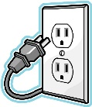  Unplug Chargers | Simply turning off your TV, DVD player, stereo, and unplugging your iPod and cell phone charger when not in use, will save you thousands of pounds of CO₂ a year. | Flip that Switch | Turn off your lights when you don’t need them. Lighting, most of which is from inefficient incandescent lights, uses about 25% of all electricity in the United States. Electricity is produced mostly by burning fossil fuels.
Spread the Word! | Talk to your friends, family, and school teachers. Teach them what you've learned and make your house and school as green as possible. Think of ways to raise awareness & educate others to make a difference in your local community. | 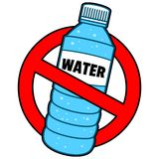  No More  Plastic Bottles | If you look at the life cycle of a plastic bottle, you’ll find that making, transporting, using, and throwing away the bottle all result in CO₂ emissions—but mostly transportation. Bottles with water or soda in them are heavy! Moving bottles requires trucks and a lot of fossil fuel. Opt for a reusable bottle!
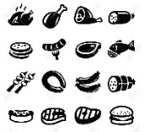  Eat Less Meat | Animal agriculture is responsible for 18% of greenhouse gases. That’s more than the combined exhaust of all transportation! When you eat less meat, you save fossil fuel and keep more greenhouse gases out of Earth’s atmosphere. | Eat Local | Ask your parents to visit a farm stand or farmer’s market. Currently, the average meal travels nearly 750 miles from the farm to plate. That’s the distance to Canada—and nearly the distance to Mexico!

